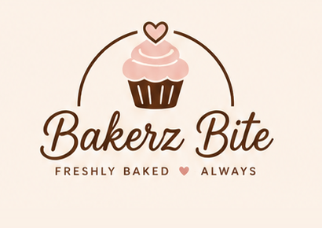
BAKERZ BITE
Premium Bakery & Café Website
Project Title: Bakerz Bite eProject
USER GUIDE
Documentation: User Guide to the Bakerz Bite Website
Group | A
Course | CPISM
Batch code | 2606E2
Institute | APTECH NN 2

TEAM MEMBERS
No. | Name | Student ID
1 | Fariha Kamran | Student1733422
2 | Fatima Irfan | Student1728977
3 | Kashaf Baig | Student1733423
4 | Ahmed Faraz Siddiqui | Student1733177

Abstract
Bakerz Bite is a responsive, multi-page website for a fictional artisan bakery and café located in Gulberg, Lahore, Pakistan. It was developed as a front-end project with HTML5, CSS3 (Bootstrap 5.3) and vanilla JavaScript, and it also demonstrates jQuery (back-to-top button) and XML (a product catalogue parsed in the browser). The website contains 26 pages and a catalogue of 56 products in 14 categories.
Visitors can choose their delivery or pick-up location, browse and search the menu, filter by price, rating and dietary needs, customise products (size, frosting, flavour, decorations and a cake message), save favourites to a wishlist, add items to a cart with automatic offers and delivery charges, and complete a validated checkout with Cash on Delivery or an online payment form. The checkout is simulated and gives an order reference such as BB-5967.
Product data is stored in JSON and JavaScript data files, and the cart, theme, wishlist, reviews and location are saved in the browser’s localStorage, so no server or database is needed. This User Guide explains the purpose and scope of the website, its users, the system requirements, how to open and navigate it, how to use every main page with screenshots, how the main activities work through flowcharts and data flow diagrams, and how to solve common problems.

Acknowledgement
We would like to express our sincere gratitude to our instructor and the faculty of APTECH NN 2 for their continuous guidance, valuable feedback and encouragement throughout the CPISM course and the Bakerz Bite project.
We also thank APTECH NN 2 for providing the learning environment and resources, and our families and classmates for their support and motivation. Finally, we are grateful to the open-source community behind Bootstrap, jQuery and Google Fonts, whose tools helped us to build this project.
Group A, Batch 2606E2
Fariha Kamran · Fatima Irfan · Kashaf Baig · Ahmed Faraz Siddiqui
Table of Contents

Abstract i
Acknowledgement ii
1. Introduction 1
1.1 Introduction to the Website 1
1.2 Purpose of the Website 1
1.3 Scope of the Website 1
2. Project Overview 3
2.1 What the Website Provides 3
2.2 Main User Journey 3
2.3 Main Website Sections 4
3. Target Users 5
3.1 Who Can Use the Website 5
3.2 How the Website Helps Each User Group 5
4. System Requirements 6
4.1 Hardware Requirements 6
4.2 Software Requirements 6
4.3 Browser Requirements 6
5. Getting Started 7
5.1 How to Open the Website 7
5.2 What the User Sees First 7
5.3 How to Navigate the Website 8
6. Website Navigation 9
6.1 Main Navigation Bar 9
6.2 Top-Bar Controls, Bottom Bar and Footer 9
7. Website Pages 10
7.1 Home Page 10
7.2 About Us 11
7.3 Contact 12
7.4 Menu / Products 12
7.5 Gallery 15
8. Diagrams 16
8.1 Flowchart: Overall User Journey 16
8.2 Flowchart: Adding Items to the Cart 17
8.3 Flowchart: Cart and Checkout 18
8.4 Data Flow Diagram: Level 0 (Context Diagram) 19
8.5 Data Flow Diagram: Level 1 20
9. Common User Issues and Solutions 21
10. Conclusion 22

1. Introduction

1.1 Introduction to the Website
Bakerz Bite is a premium bakery and café website with the tagline “A Little Sweetness, Made Beautiful”. It presents the bakery’s products, prices, offers, story, gallery, reviews and contact details in a warm, modern design that works on mobile phones, tablets and desktop computers. Visitors can browse cakes, cupcakes, pastries, croissants, donuts, cookies, breads, pizza, pies and tarts, coffee, tea, hot and cold drinks and merchandise, add their choices to a cart and place an order through a checkout.
The website has 26 pages: index.html (home page) and 25 pages in the html folder. One shared script (script.js) reads the data files and builds the header, product cards, cart and checkout on every page, so all pages look and behave in the same way.

1.2 Purpose of the Website
The purpose of Bakerz Bite is to give a bakery and café a modern online presence where customers can discover products, see prices, ingredients and allergens, personalise their order and place it online. It helps customers by providing:
- Easy discovery: search, filters and categories to find the right product quickly.
- Clear information: prices, ratings, ingredients and allergens in one place.
- Personalised orders: size, frosting, flavour, decorations and a message on the cake, with a live price.
- Clear costs: automatic offers, delivery fee (free above Rs. 5,000) and the final total in the cart.
- Convenience: delivery or pick-up, open / closed status and ordering from any device.

1.3 Scope of the Website
The website is a front-end project. The table below shows what is included and what is outside the current version.
Included in the scope | Not included (future scope)
26 responsive pages: Home, Menu, 14 category pages, Offers, About Us (Our Story), Gallery, Reviews, Contact, FAQ, Cart, Privacy, Terms, Sitemap | Real back end and database
56 products with search, sort, rating and price filters, best-seller / new / sale filters and dietary filters | User registration and login
Product window with options and live price; wishlist | Real online payment gateway
Cart with quantity control, automatic offers and delivery rule | Real order tracking, e-mail or SMS sending
Validated checkout: Delivery / Pick-up, time slot, Cash or Online Payment form (simulated) | Admin panel to manage products and orders
Welcome screen and location chooser, live open / closed bar, light and dark theme, visitor counter | More cities and languages
Gallery with lightbox, FAQ, reviews, contact and newsletter forms, accessibility features

2. Project Overview

2.1 What the Website Provides
Feature | Description
Product catalogue | 56 products in 14 categories with photos, prices, ratings, ingredients, allergens and badges such as Best Seller, New and Sale.
Search, sort and filters | Search by name or ingredient; sort by featured, price or top rated; filter by rating, maximum price, Best Sellers, New Arrivals, On Sale, My Wishlist and dietary needs.
Customisation | Choose size, frosting, flavor, optional decorations, quantity and a message on the cake; the total updates immediately.
Cart and offers | Cart drawer and Cart page with quantity control, automatic offers, delivery fee and total. Delivery is free above Rs. 5,000, otherwise Rs. 250.
Checkout (simulated) | Form with validation, Delivery or Pick-up, preferred time, Cash on Delivery / Cash at Pick-up or Online Payment (card form). An order reference such as BB-5967 is shown.
Wishlist and reviews | Save favourites with the heart button; read customer reviews and write your own with a star rating.
Location and live information | Welcome screen and location chooser; bottom bar with open / closed status, date, time and location.
Themes and accessibility | Light and dark theme, skip link, ARIA labels, keyboard support and reduced-motion support.

2.2 Main User Journey
A typical visitor moves through the website in these steps:
- Open the website and watch the short welcome screen.
- Choose the location: Delivery or Pick-up, city (Karachi, Hyderabad or Lahore) and area or branch, then click Continue to Website.
- Explore the home page or use the navigation bar to open the Menu.
- Find products with category chips, search, sort and filters.
- Open a product to read details, choose options and add it to the cart (or save it with the heart).
- Review the cart to check quantities, offers, delivery fee and total.
- Check out by entering details, choosing a payment method and clicking Confirm order.

2.3 Main Website Sections
Section | Pages and purpose
Home | index.html: hero banner, collections, best sellers, new arrivals, featured treats, how ordering works, offers, gallery preview, guest reviews and newsletter.
Menu | All 56 products with category chips, search, sort and filters.
Category pages (14) | Cakes, Cupcakes, Pastries, Cookies, Pies & Tarts, Croissants, Breads, Donuts, Pizza, Hot Drinks, Coffee, Tea, Cold Drinks and Merchandise.
Offers | Eight offers and combos such as Celebration Cake Deal, Pastry Pair and Free Delivery over Rs. 5,000.
About Us | The Our Story page: the bakery’s story, journey and bakers.
Gallery | Photo gallery with category filters and a lightbox.
Reviews | Average rating, customer reviews and a Write a Review form.
Contact | Visit & Contact details and a Send a message form.
Support pages | FAQ, Cart, Privacy, Terms and Sitemap.

3. Target Users

3.1 Who Can Use the Website
Anyone with a web browser can use Bakerz Bite. No account, login or special skill is required. The website is designed mainly for bakery and café customers who browse on a mobile phone, tablet or computer.

3.2 How the Website Helps Each User Group
User group | How the website helps
Bakery and café customers | See products, prices, offers and opening status in one place and order from any device.
Customers with dietary needs | Use Egg-free, Nut-free, Dairy-free, Gluten-free and Vegan filters and read ingredients and allergens before choosing.
Customers who order celebration cakes | Choose size, frosting, decorations and a cake message with a live price, and use the Celebration Cake Deal.
Customers who prefer pick-up | Choose Pick-up and a branch, then pay cash at pick-up or use the online payment form.
Users who need accessibility support | Skip link, keyboard access, ARIA labels, reduced motion and a dark theme for comfortable viewing.
The bakery team | Products, offers, FAQs and contact details are stored in separate data files, which makes the website easy to update without a server.

4. System Requirements

4.1 Hardware Requirements
Component | Minimum | Recommended
Processor | Dual-core 1.6 GHz | Intel Core i5 / Ryzen 5 or better
RAM | 4 GB | 8 GB or more
Storage | 500 MB free (project images and videos) | 2 GB free
Display | 1366 × 768 (phones and tablets also supported) | 1920 × 1080
Internet | Needed for Bootstrap, Google Fonts and jQuery files | Broadband

4.2 Software Requirements
Item | Requirement
Operating system | Windows 10 / 11, macOS or Linux (Android and iOS for viewing)
Project files | The project folder extracted from the .zip file, with index.html, html, css, js, data, images and videos kept together
Code editor (optional) | Visual Studio Code
VS Code extension (optional) | Live Server, to run the website over http:// (needed for the XML catalogue demo)
Browser settings | JavaScript and localStorage enabled (default); private mode may not keep the cart

4.3 Browser Requirements
Any modern browser that supports localStorage, fetch, CSS Grid / Flexbox and CSS variables: Google Chrome 90+ (recommended), Microsoft Edge 90+, Mozilla Firefox 88+, Safari 14+, or mobile Chrome / Safari.

5. Getting Started

5.1 How to Open the Website
Option A: open the file directly
- Extract the project .zip file and open the bakerz-bite folder.
- Double-click index.html. The website opens in your default browser.

Option B: use Visual Studio Code (recommended)
- Open Visual Studio Code and choose File > Open Folder, then select the bakerz-bite folder.
- Install the Live Server extension (only once).
- Right-click index.html and choose “Open with Live Server”. The website opens at http://127.0.0.1:5500.
Note: an internet connection is needed to load Bootstrap, Google Fonts and jQuery. Without it the website still works but may look plainer.

5.2 What the User Sees First
When the website opens, the user first sees a short welcome screen with the Bakerz Bite logo, the words “Welcome to Bakerz Bite” and the tagline “Where Smiles Are Served Daily.” After about three seconds it changes to the location screen.
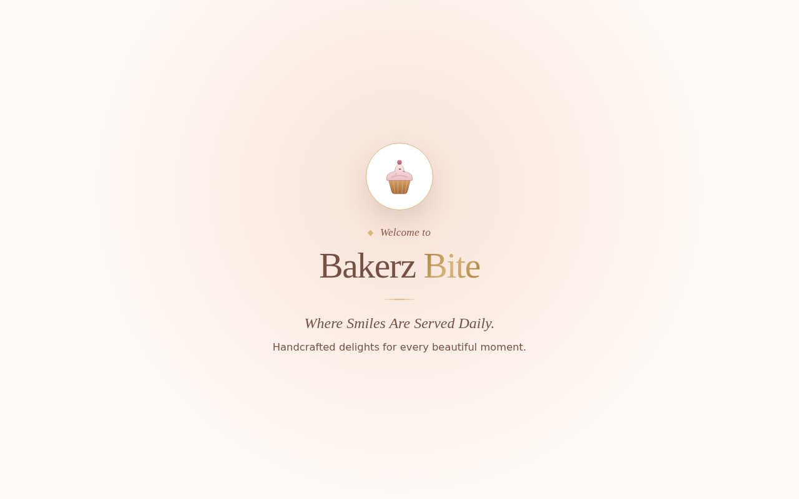
Figure 1: Welcome screen shown when the website opens
On the location screen (“Where should we prepare your order?”) the user chooses Delivery or Pick-up, then either clicks Use Current Location or selects Karachi, Hyderabad or Lahore. Next the delivery area (or the pick-up branch) is chosen from the list. The Continue to Website button becomes active after the area is selected. The choice is saved in the browser.
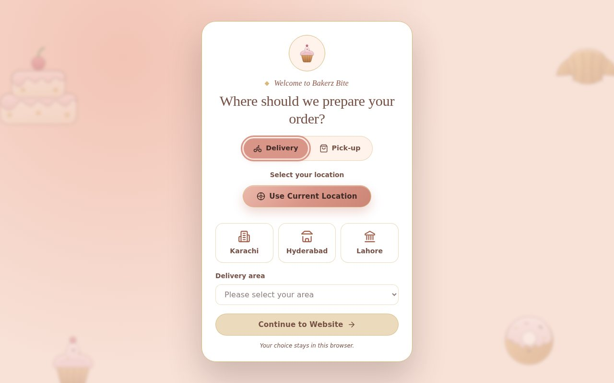
Figure 2: Location screen
After clicking Continue to Website, the home page opens.

5.3 How to Navigate the Website
- Navigation bar: click Home, Menu, Offers, About Us, Gallery, Reviews or Contact to move between pages. On a phone, tap the menu button to open the same links.
- Top-bar buttons: visitor counter, light / dark theme button, heart (wishlist) and bag (cart).
- Home page buttons: Explore Our Menu opens the menu; Discover Our Story opens the About Us page.
- Bottom bar: open / closed status, date, time and the Share location / Change location button.
- Footer: links to Explore, Help (FAQ, Reviews, Cart, Sitemap, Privacy Policy, Terms & Conditions), contact details, newsletter and category links.
- Back-to-top button: a small arrow appears after scrolling down and returns you to the top.

6. Website Navigation
All 26 pages share the same header, bottom bar and footer, so navigation works in the same way on every page.

6.1 Main Navigation Bar
Menu item | Where it takes you
Home | Home page (index.html)
Menu | All products with search, sort and filters, plus 14 category pages
Offers | Offers and combo deals
About Us | Our Story page
Gallery | Photo gallery with lightbox
Reviews | Customer reviews and the Write a Review form
Contact | Contact details and message form

6.2 Top-Bar Controls, Bottom Bar and Footer
Control | What it does
Visitor counter (logo with a number) | Shows how many visits the website has counted in this browser.
Moon / sun button | Switches between light and dark theme; the choice is remembered.
Heart button | Opens the menu filtered to My Wishlist (saved products).
Bag button | Opens the cart drawer; a small badge shows the number of items.
Menu button (phones) | Opens and closes the navigation links on small screens.
At the bottom of every page a live bar shows whether the bakery is open (“Open now · closes 10:00 PM”), the date, the time and the saved location, with a Share location / Change location button. The footer has links to the main and support pages (FAQ, Cart, Sitemap, Privacy Policy, Terms & Conditions), contact details, a newsletter box and links to all categories.

7. Website Pages
This chapter explains the main pages of the website with screenshots and shows how to use each of them.

7.1 Home Page
The home page introduces the brand and leads visitors to the menu and the story page. It opens in the light theme; the moon button switches the whole website to the dark theme.
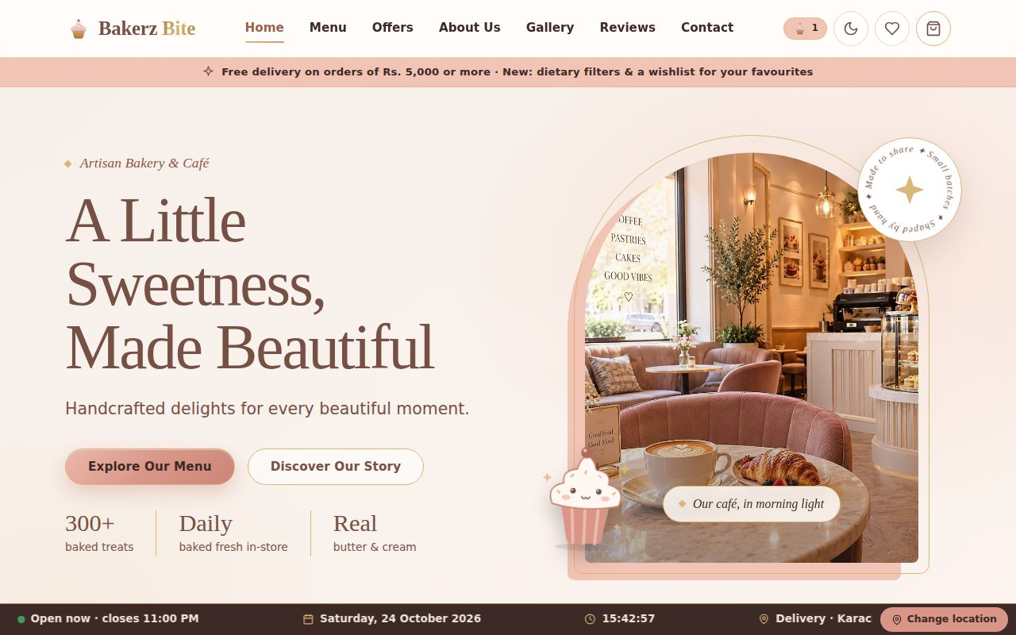
Figure 3: Home page with hero banner, Explore Our Menu and Discover Our Story buttons
Sections of the home page, from top to bottom:
- Announcement bar: free delivery on orders of Rs. 5,000 or more.
- Hero banner: the heading “A Little Sweetness, Made Beautiful”, the buttons Explore Our Menu and Discover Our Story, and a photo slideshow.
- Our Collections: round category pictures; click one to open that category.
- Best Sellers, New Arrivals and Featured Treats: product cards with price and a View details button.
- How Ordering Works: three simple steps to order.
- Offers, gallery preview, guest reviews and newsletter: shortcuts to the other pages.

7.2 About Us
The About Us page (Our Story) tells visitors how Bakerz Bite started. Open it from About Us in the navigation bar or from the Discover Our Story button. It shows the story “It started with one oven”, figures about the bakery and the Our Journey timeline from a tiny kitchen in 2019 to the café in Gulberg, Lahore.
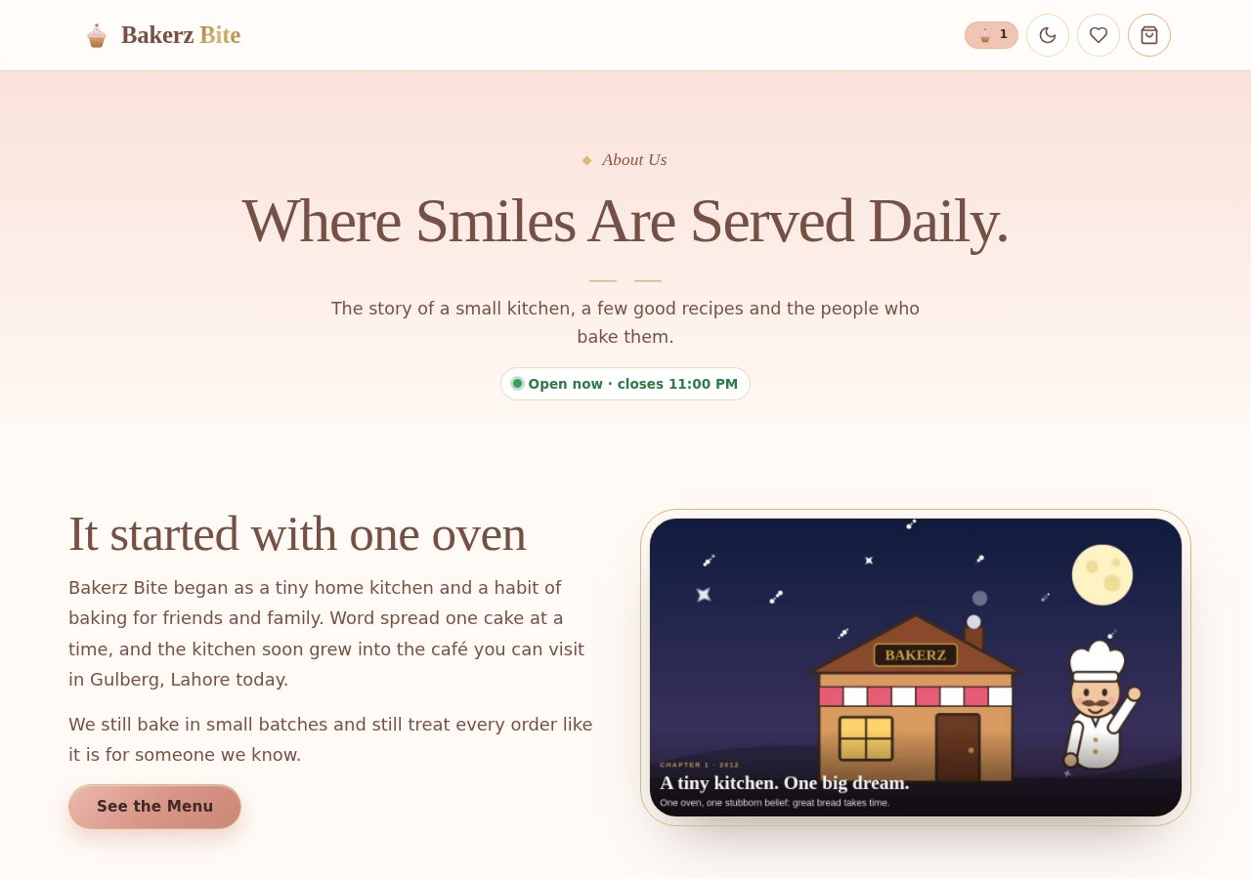
Figure 4: About Us page

7.3 Contact
The Contact page has two cards. Visit & Contact shows the e-mail, phone, address and opening hours (Monday – Friday 8:00 AM – 10:00 PM, Saturday – Sunday 9:00 AM – 11:00 PM; sample data). Send a message has Name, Email, Subject and Message fields and a Send message button. If a field is empty or wrong, a red message appears under it.
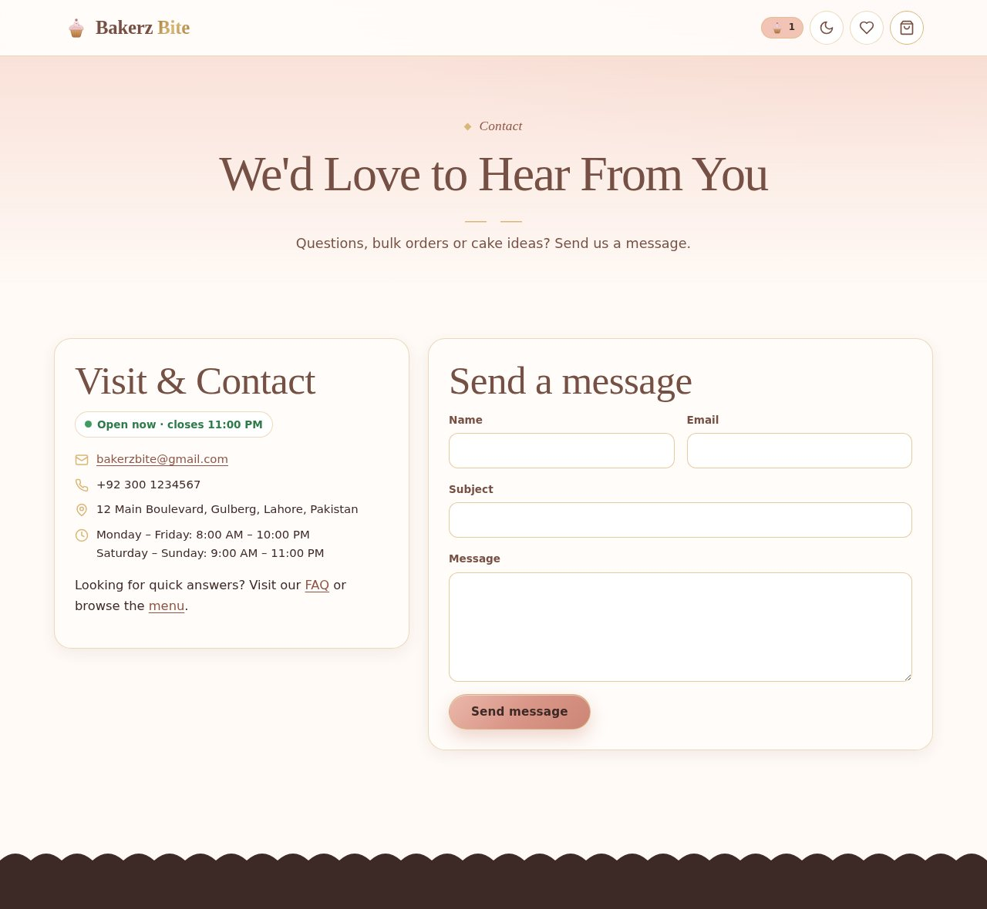
Figure 5: Contact page with contact details and message form

7.4 Menu / Products
The Menu page lists all 56 products. Use the category chips to show one category, the Search box for names or ingredients, and the Sort by, Rating and price slider controls. The chips Best Sellers, New Arrivals, On Sale and My Wishlist and the Dietary needs chips (Egg-free, Nut-free, Dairy-free, Gluten-free, Vegan) narrow the list further. Clear filters resets everything.
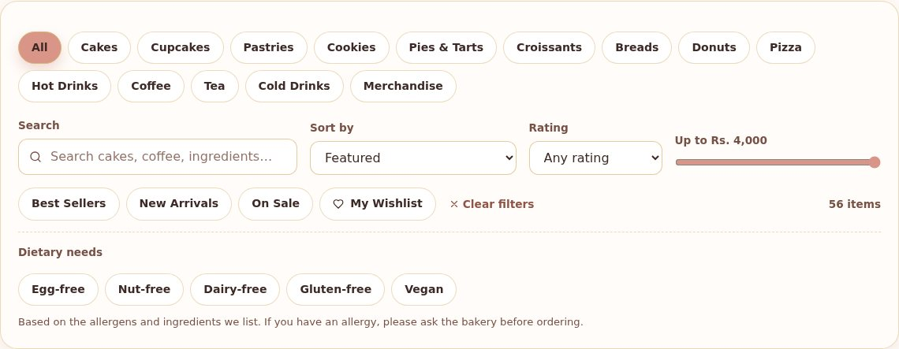
Figure 6: Menu page filters
Each product card shows a photo, name, description, rating, price and a Customize or Add to Cart button. The heart on the photo saves the product to the wishlist.
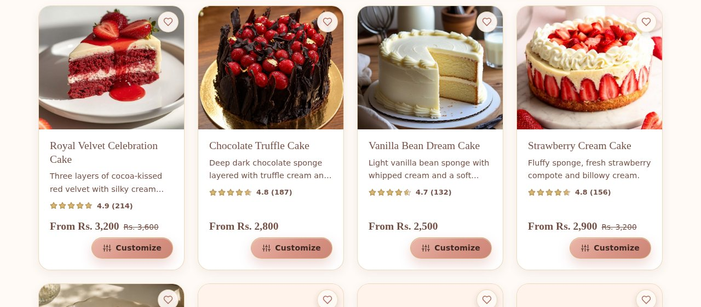
Figure 7: Product cards on the Menu page
Click a card to open the product window. It shows ingredients and possible allergens. Choose the required options (for a cake: Size and Frosting), optional decorations and the quantity; the total updates immediately. Then click Add to Cart.
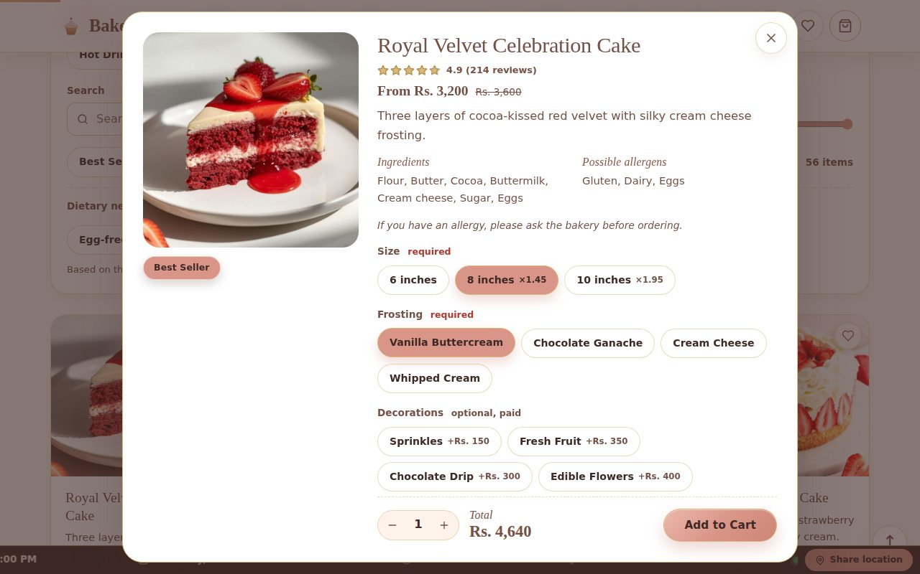
Figure 8: Product details window with options and live total
Click the bag button to open the cart drawer. Change quantities, remove items and check the subtotal, automatic offer (for example Celebration Cake Deal 15% off), delivery fee and total. Checkout starts the order.
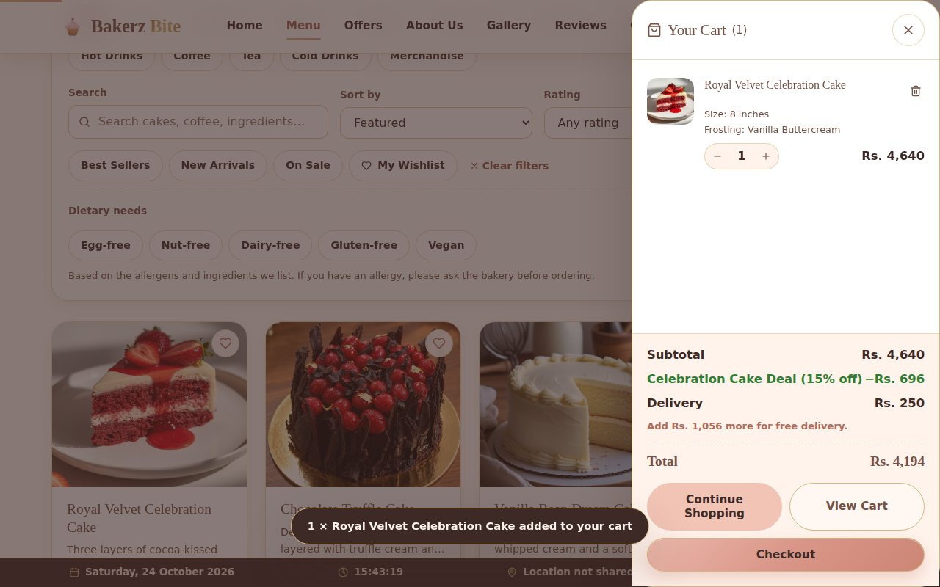
Figure 9: Cart drawer
The checkout form asks for name, phone, e-mail, address, city, preferred time and delivery instructions, and offers Cash on Delivery or Online Payment (card form). Every field is checked and a red message appears under any wrong field.
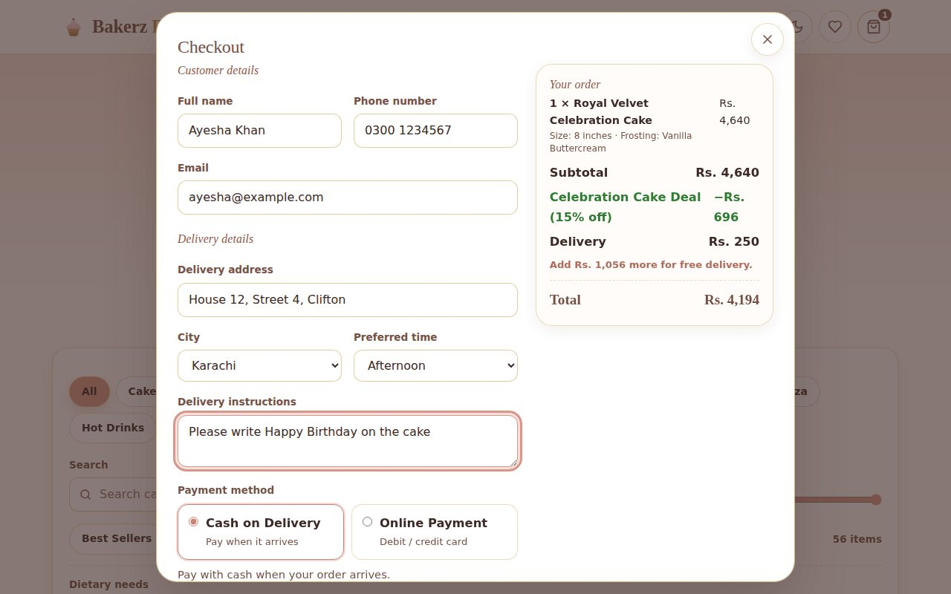
Figure 10: Checkout form
After Confirm order, the “Order confirmed” window shows the order reference, total and payment method. This is a simulated order: no real payment is taken.
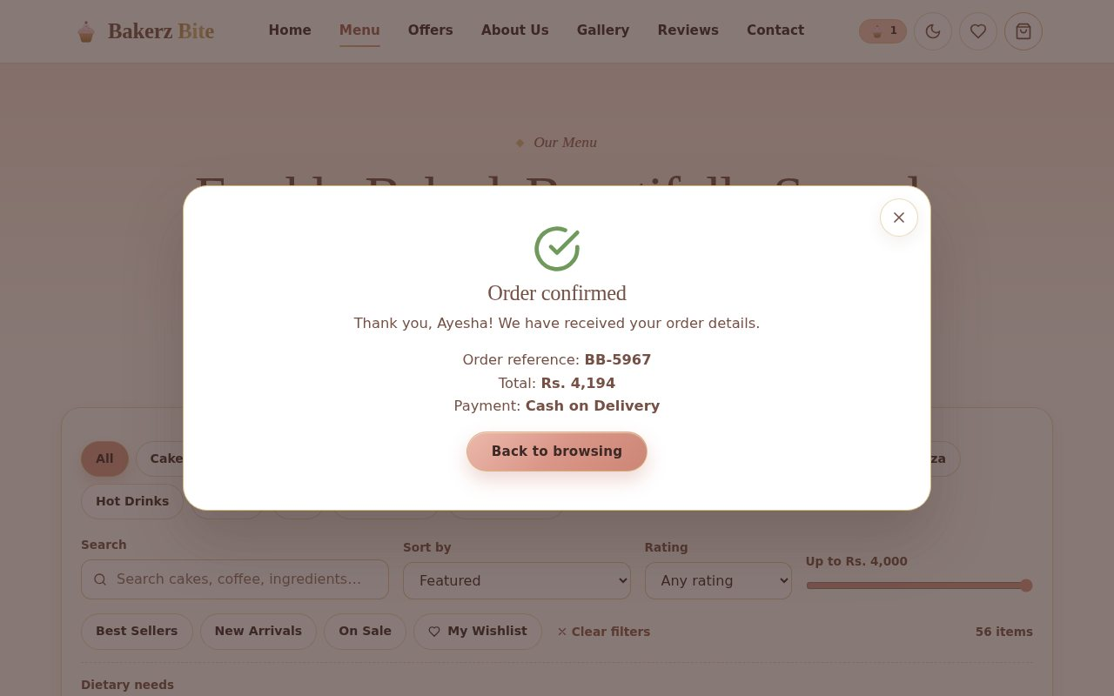
Figure 11: Order confirmed window

7.5 Gallery
The Gallery page shows 12 photographs of cakes, pastries, cookies, pizza, coffee and the bakery. Use the filter chips (for example Celebration Cakes or Pastries) to show one group, and click a photo to open it in a lightbox with previous and next arrows.
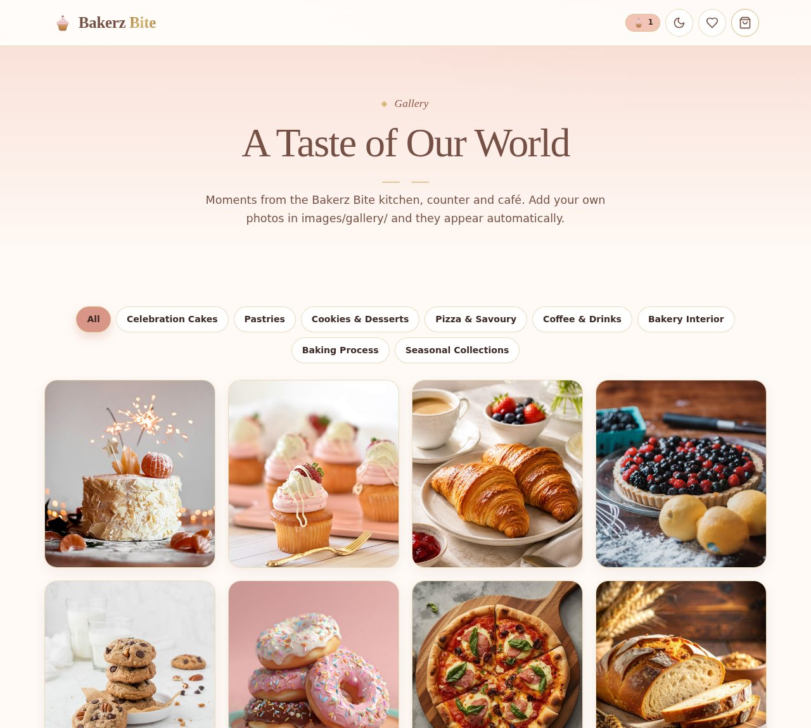
Figure 12: Gallery page with filter chips and photo grid

8. Diagrams
The flowcharts and data flow diagrams below explain how the main activities of the website work. In the flowcharts, ovals show the start and end, rectangles show actions, parallelograms show user input and diamonds show decisions.

8.1 Flowchart: Overall User Journey
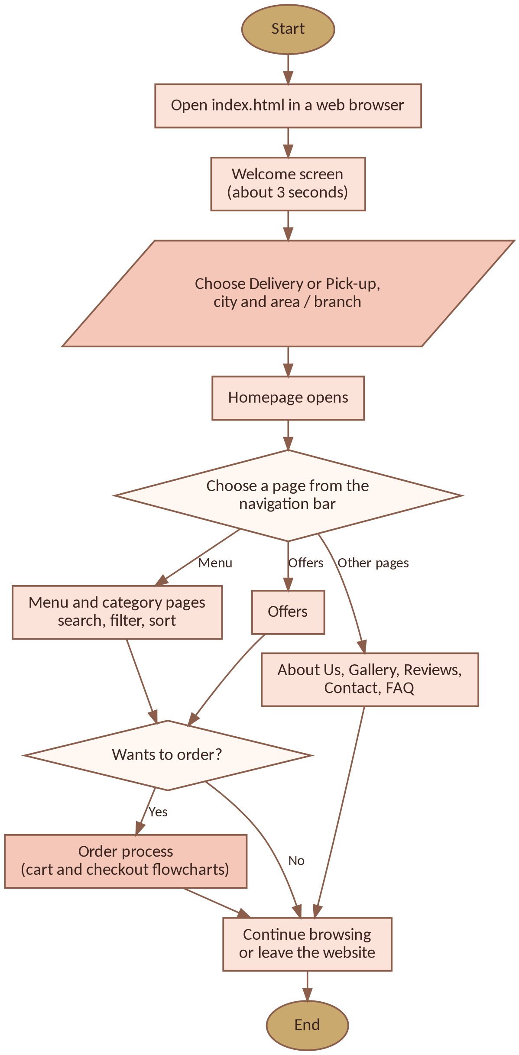
Figure 13: Flowchart of the overall user journey

8.2 Flowchart: Adding Items to the Cart
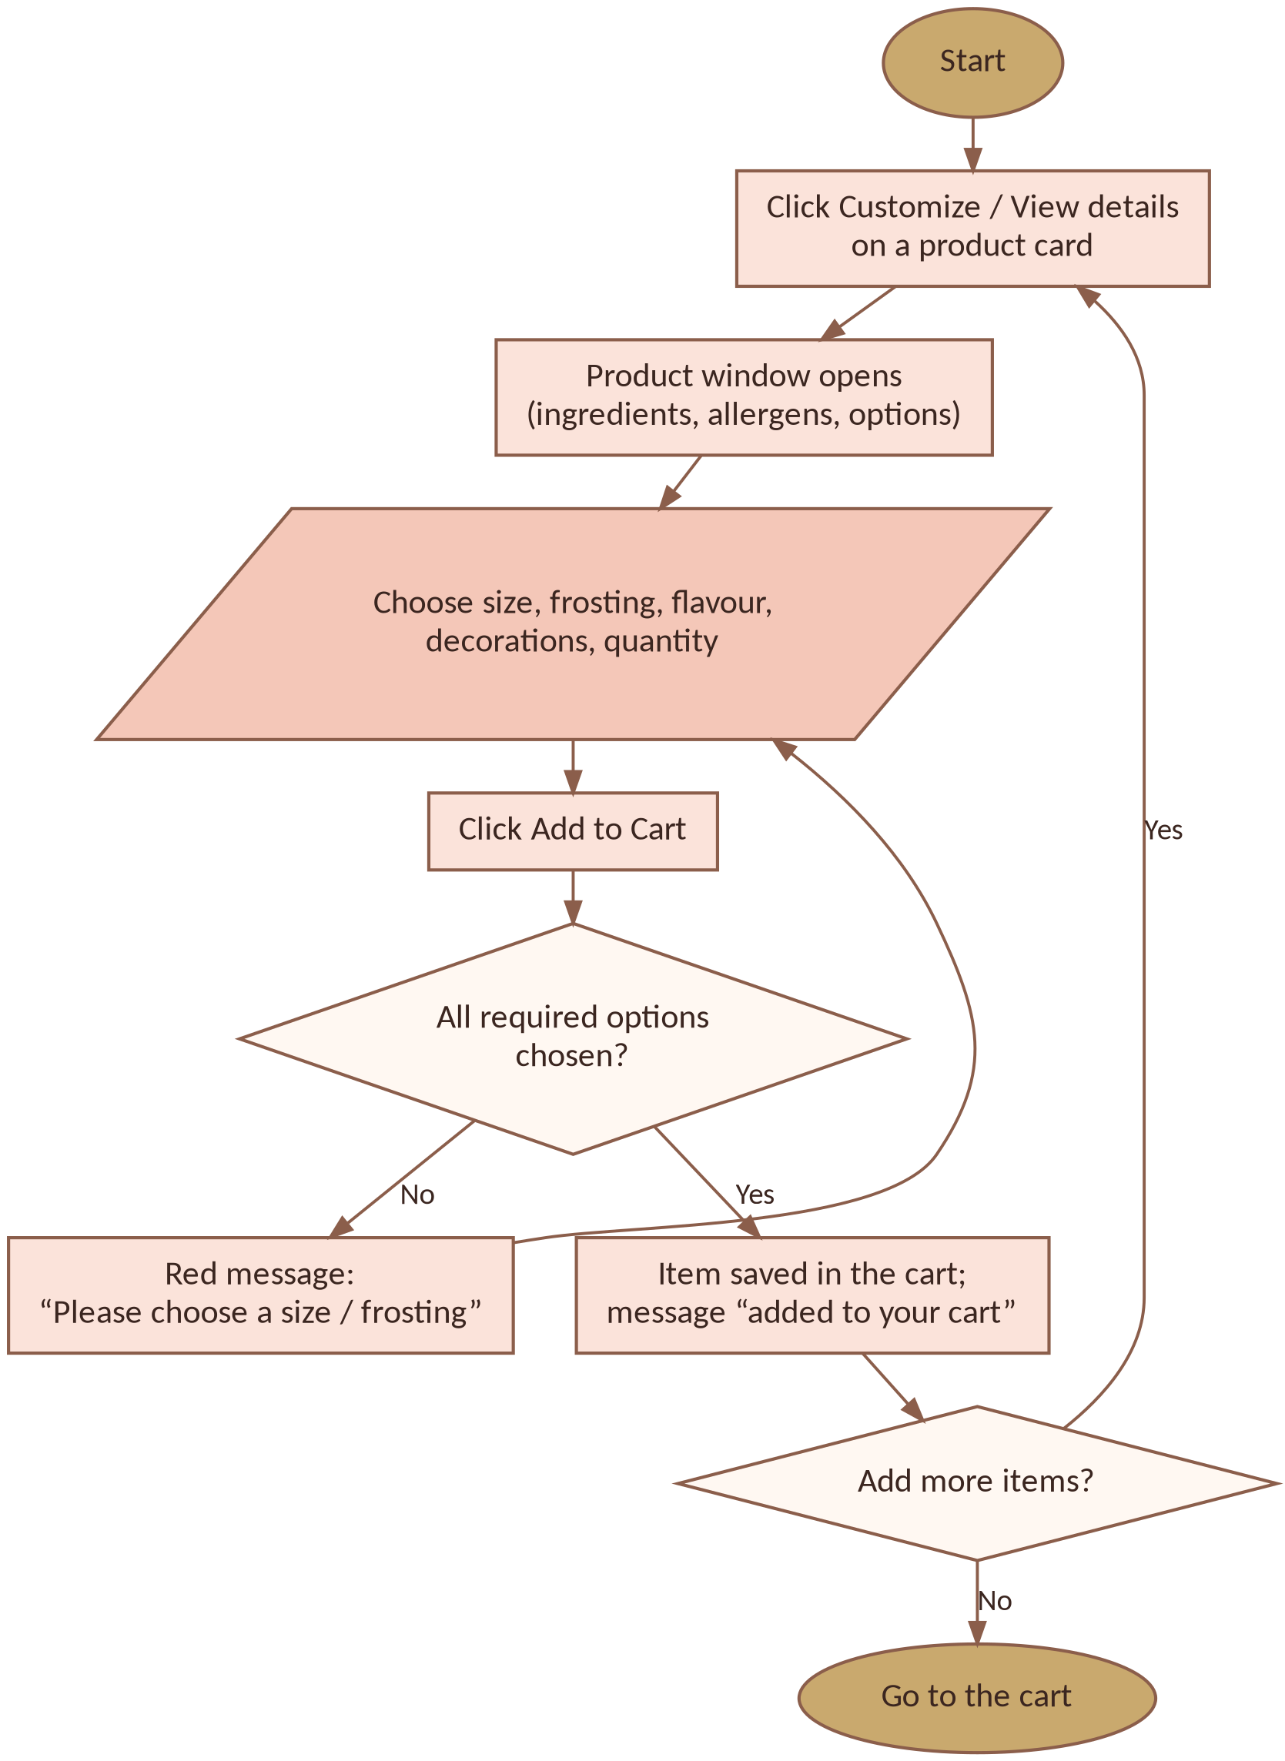
Figure 14: Flowchart for adding products to the cart

8.3 Flowchart: Cart and Checkout
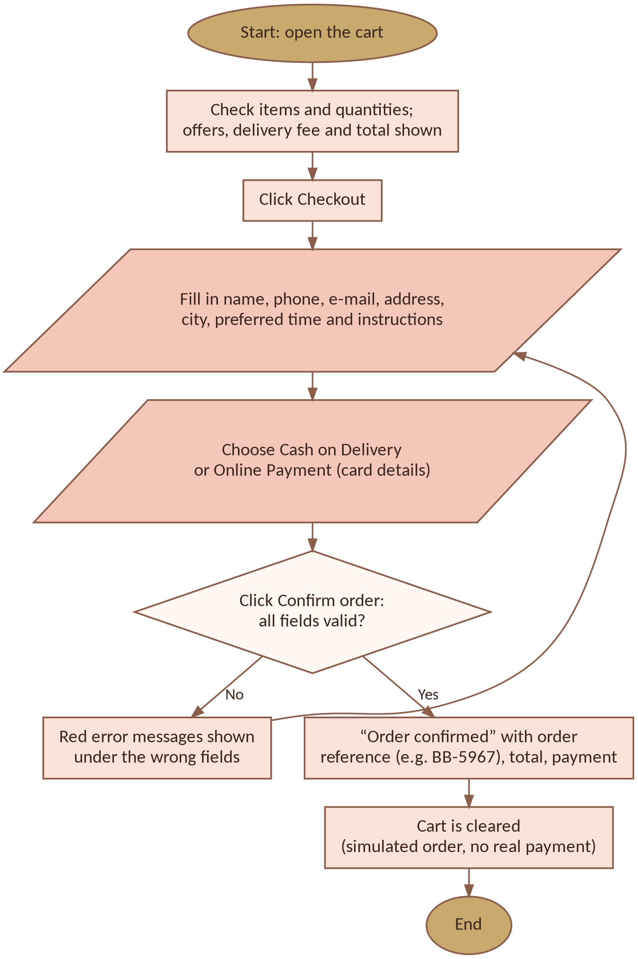
Figure 15: Flowchart for the cart and checkout process

8.4 Data Flow Diagram: Level 0 (Context Diagram)
The customer sends page requests, search and filter choices, cart actions, checkout details and reviews to the website and receives pages, product details, cart totals and order confirmation. The website reads product data from the data files (D1) and saves the cart, theme, wishlist, reviews and location in the browser’s localStorage (D2).
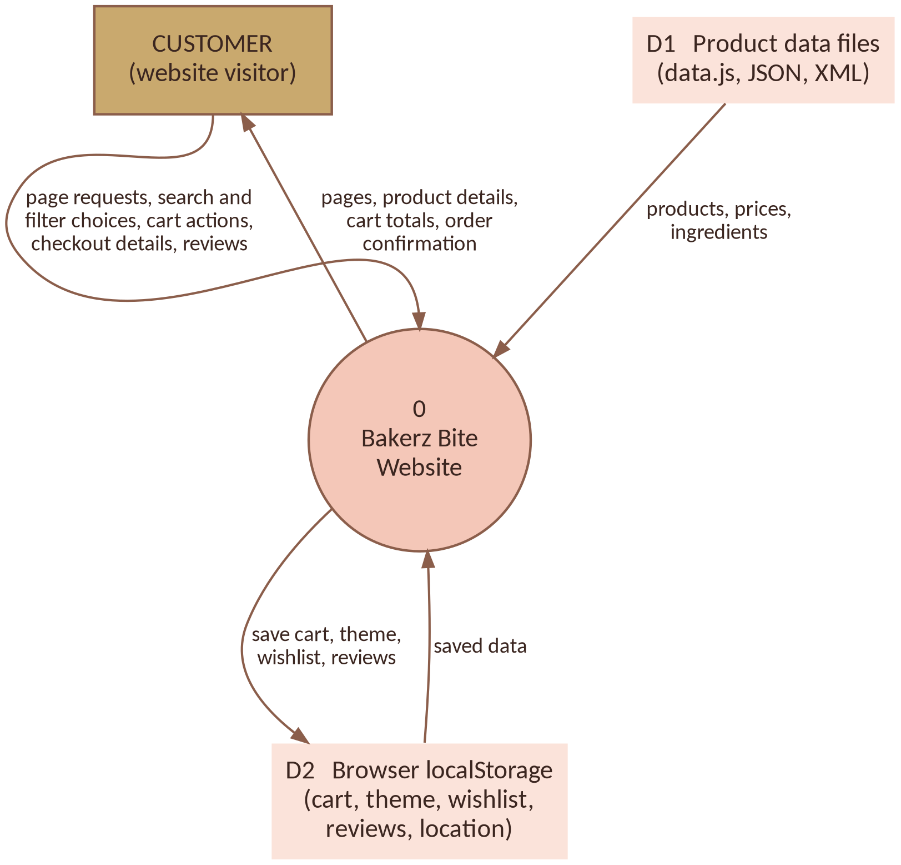
Figure 16: Data Flow Diagram, Level 0

8.5 Data Flow Diagram: Level 1
Level 1 splits the website into five processes: render the page (1.0), browse, search and filter (2.0), customise and manage the cart (3.0), validate the checkout (4.0) and save preferences (5.0).
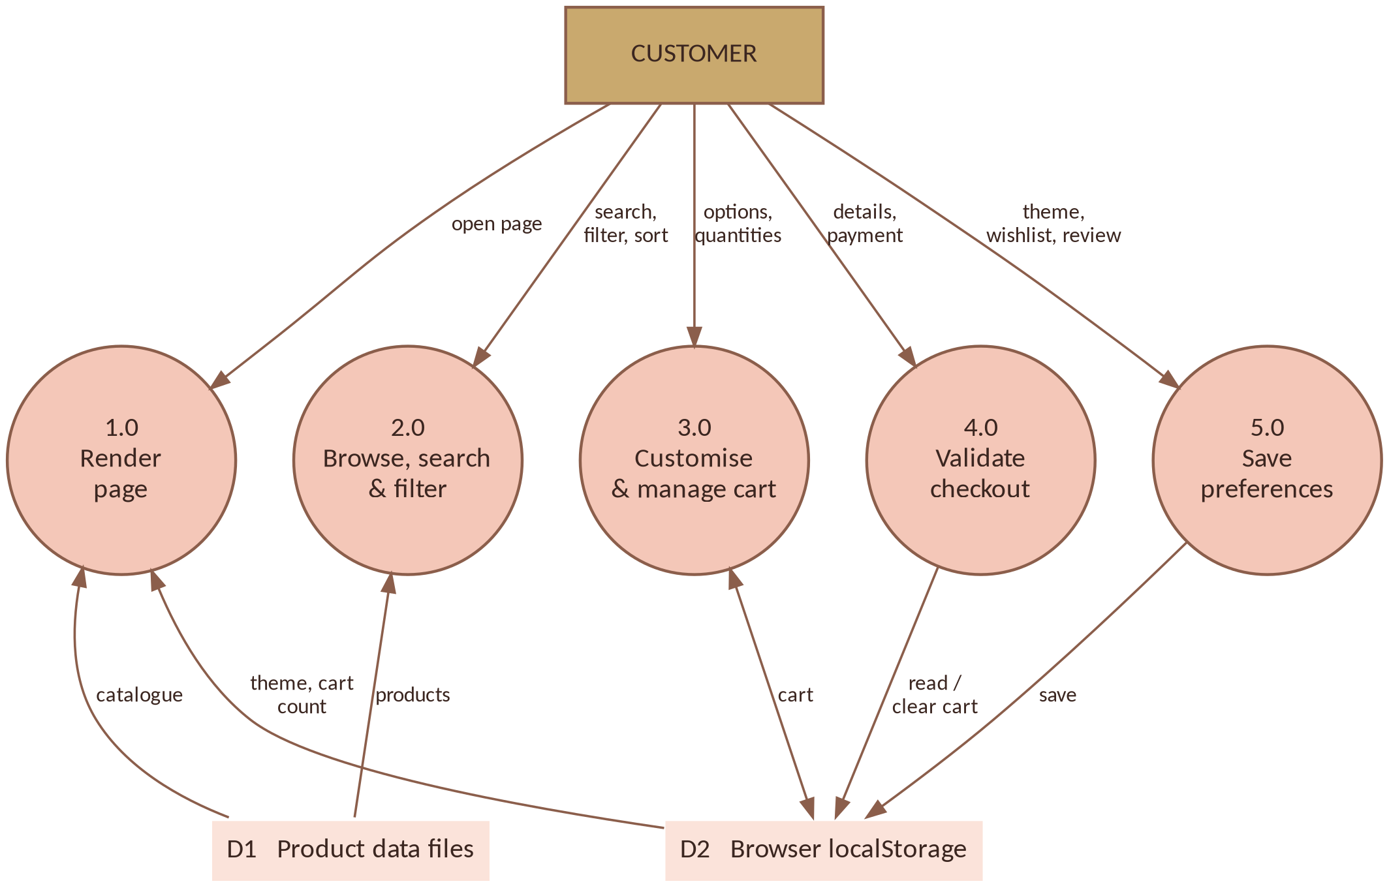
Figure 17: Data Flow Diagram, Level 1

9. Common User Issues and Solutions
Problem | Solution
The page looks plain, or fonts and images are missing | Keep the whole project folder together and check the internet connection, because Bootstrap and Google Fonts are loaded online.
Continue to Website is disabled | Select a city and then an area (or branch); the button becomes active after both are selected.
Cart is empty after closing the browser or in a private window | The cart is saved in localStorage. Private mode or clearing browser data removes it. Use a normal window.
“Please choose a size / frosting” or red messages in checkout | Select the required options in the product window, and fill every checkout field correctly, including delivery instructions.
Payment does not charge any money | This is expected. Checkout is a simulation; there is no real payment or order tracking in this version.

10. Conclusion
Bakerz Bite is a responsive, accessible 26-page bakery and café website with 56 products in 14 categories. Visitors can choose a delivery or pick-up location, search and filter the menu, read ingredients and allergens, customise products with a live price, save favourites, benefit from automatic offers and complete a validated checkout, in a light or dark theme on any device.
This User Guide has explained the purpose and scope of the website, its target users, system requirements, how to open and navigate it, how to use each page with screenshots, and how the main activities and data flow through flowcharts and data flow diagrams. The current version is front-end only; in the future it can be extended with a back end and database, user accounts, a real payment gateway, order tracking and an admin panel.
We hope this guide helps every user to enjoy the Bakerz Bite website.

